**CN5006 Lab Session Week 2 Portfolio**

Prepared by:Hiroj Bhattarai  
Date: 08-oct-2024

**Install and Open MongoDB Compass:**

* Here I installed MongoDB Compass on my machine. And I launch it and connect to the MongoDB server using:
  + **Hostname:** localhost
  + **Port:** 27017

And finally, its confirm that I am connected by seeing the dashboard.

**Create Database and Collection:**

**Task:** Create a database named peopledb and a collection named people.

Creating the new database with named data base **peopledb** and collection named **people.**

Here peopledb database with the people collection will be visible on the left-hand panel connected with localhost:27017.

You can see it below given screenshot of that dashboard:

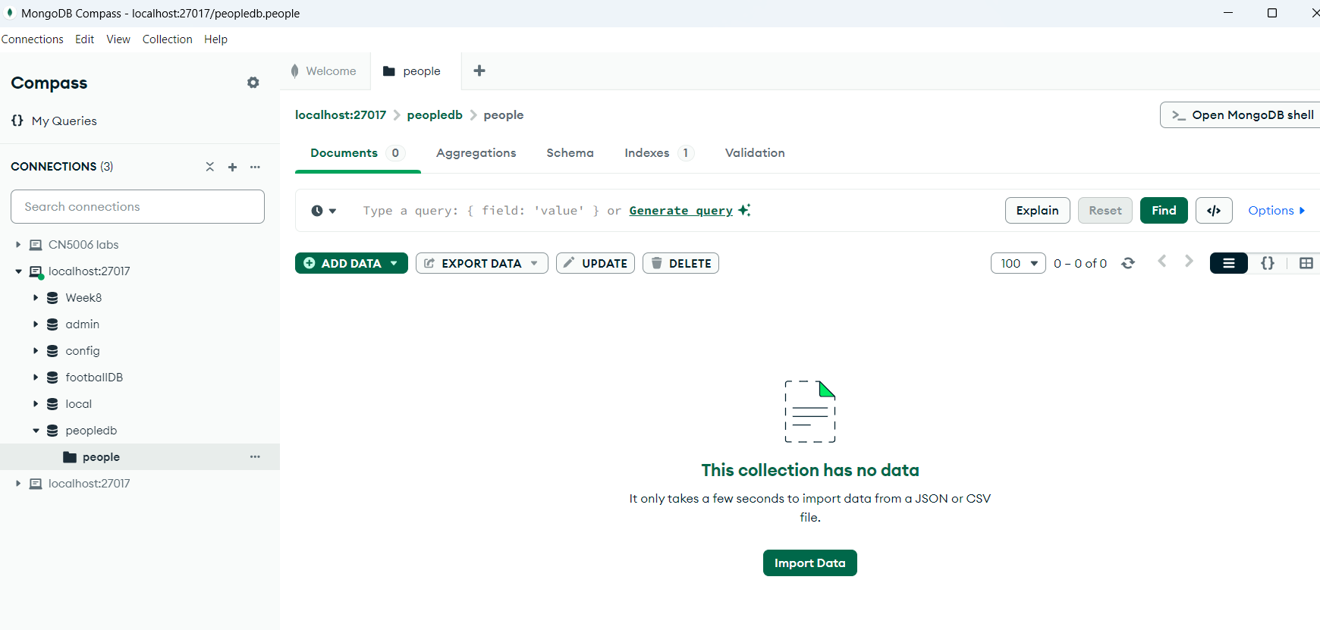

It Show the imported data in the collection, highlighting the fields

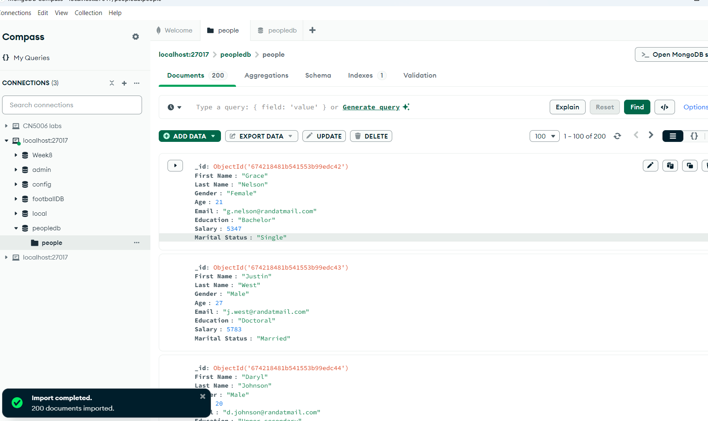

1. **Inserting document:**

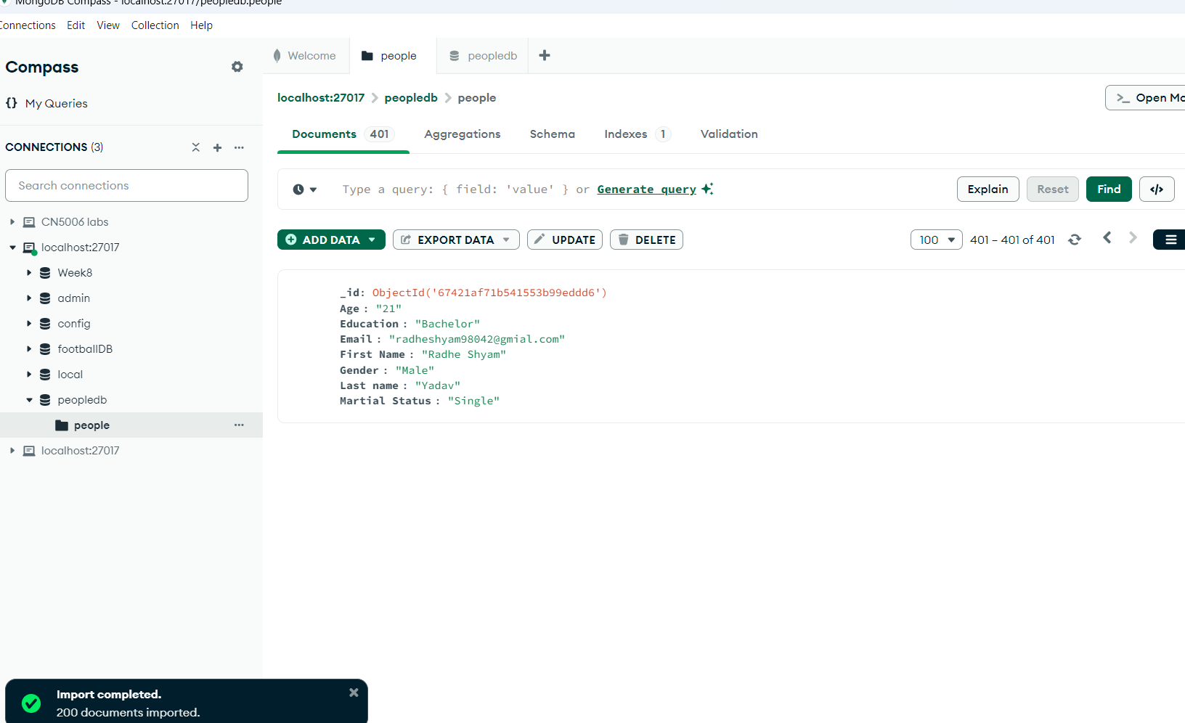

**2.Update the document**

You can see here I update my data with adding with one more new data that is salary.

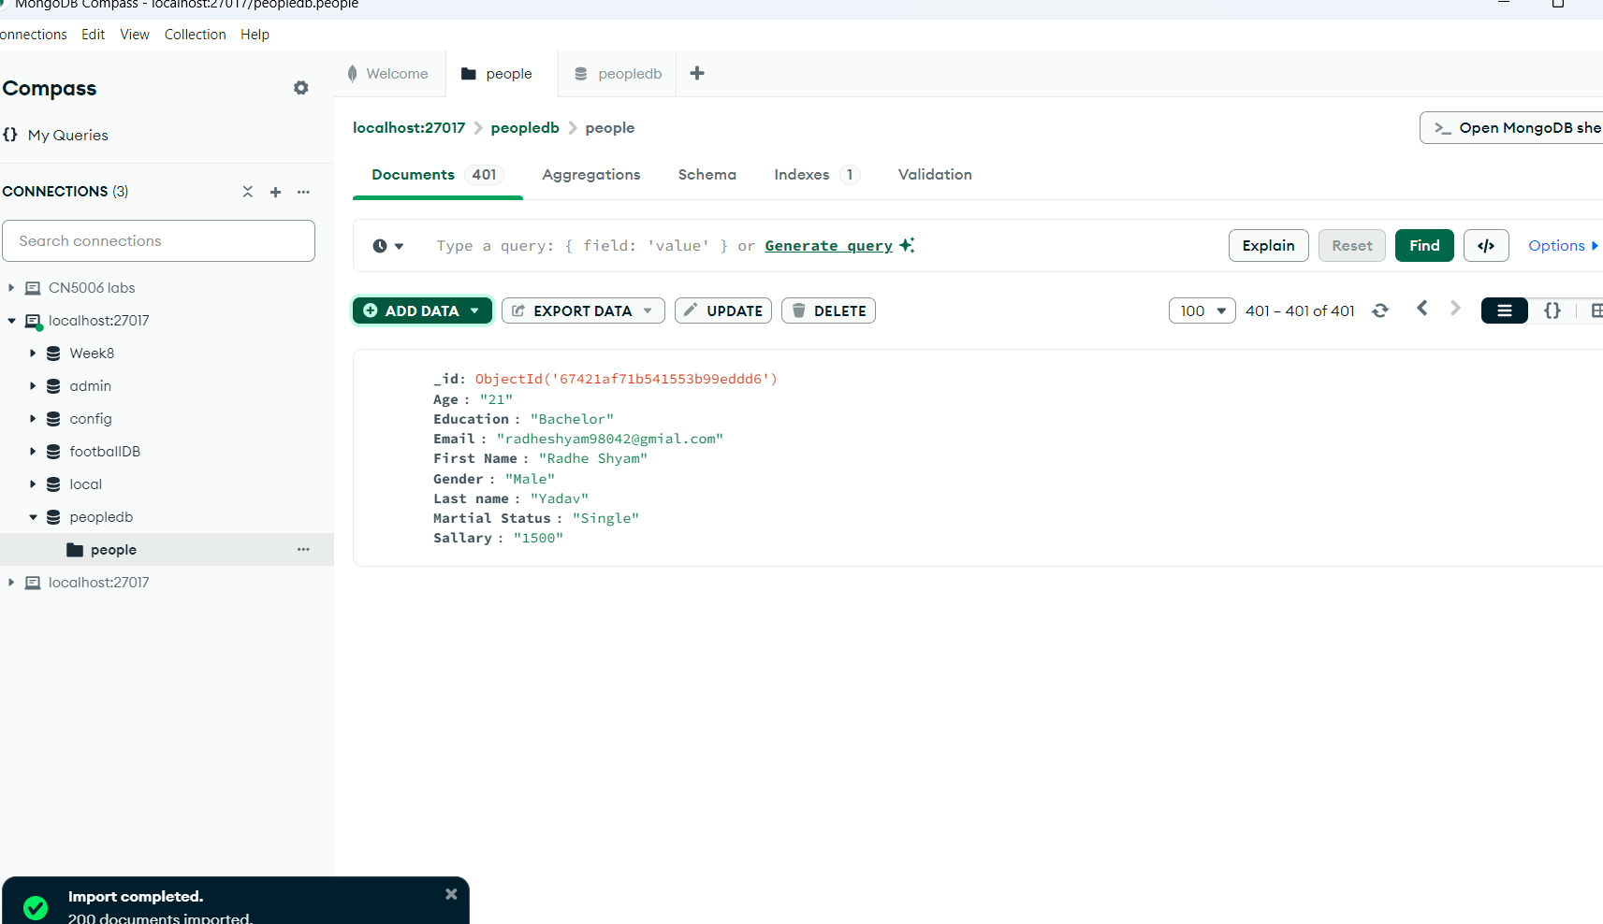

A notification you can see appear stating the document has been flagged for deletion in red. So that in the next picture there is no any data because I click on delete.

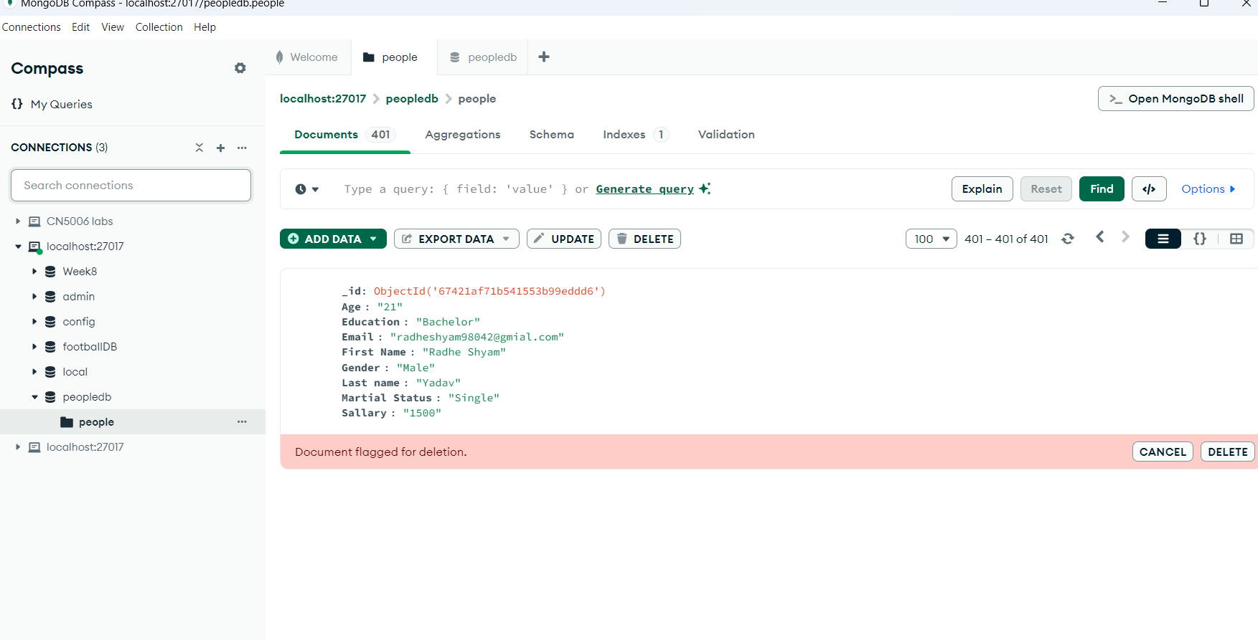

This is how it showing due to I click on the delete button and it appear no result.

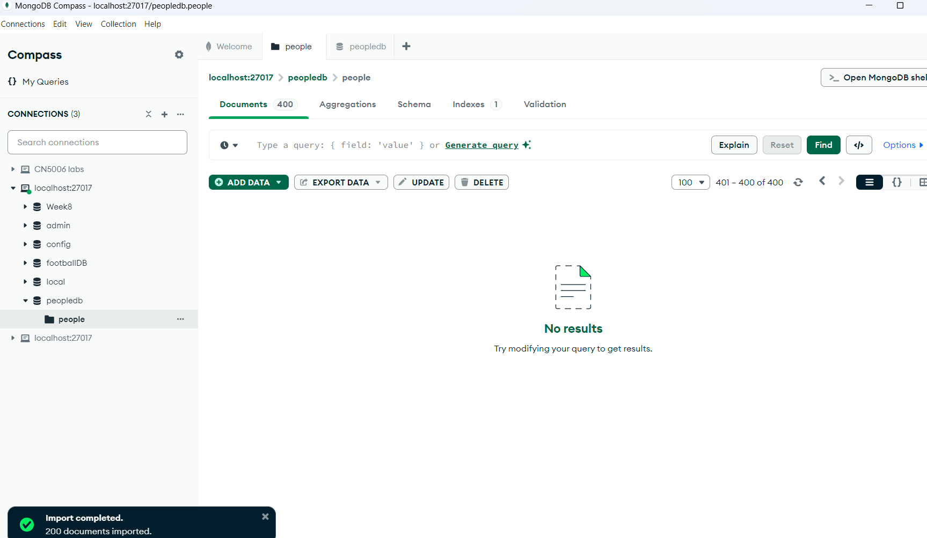

**3.Aggregations:**

**Filter for Bachelor's Degree and Age > 21:**

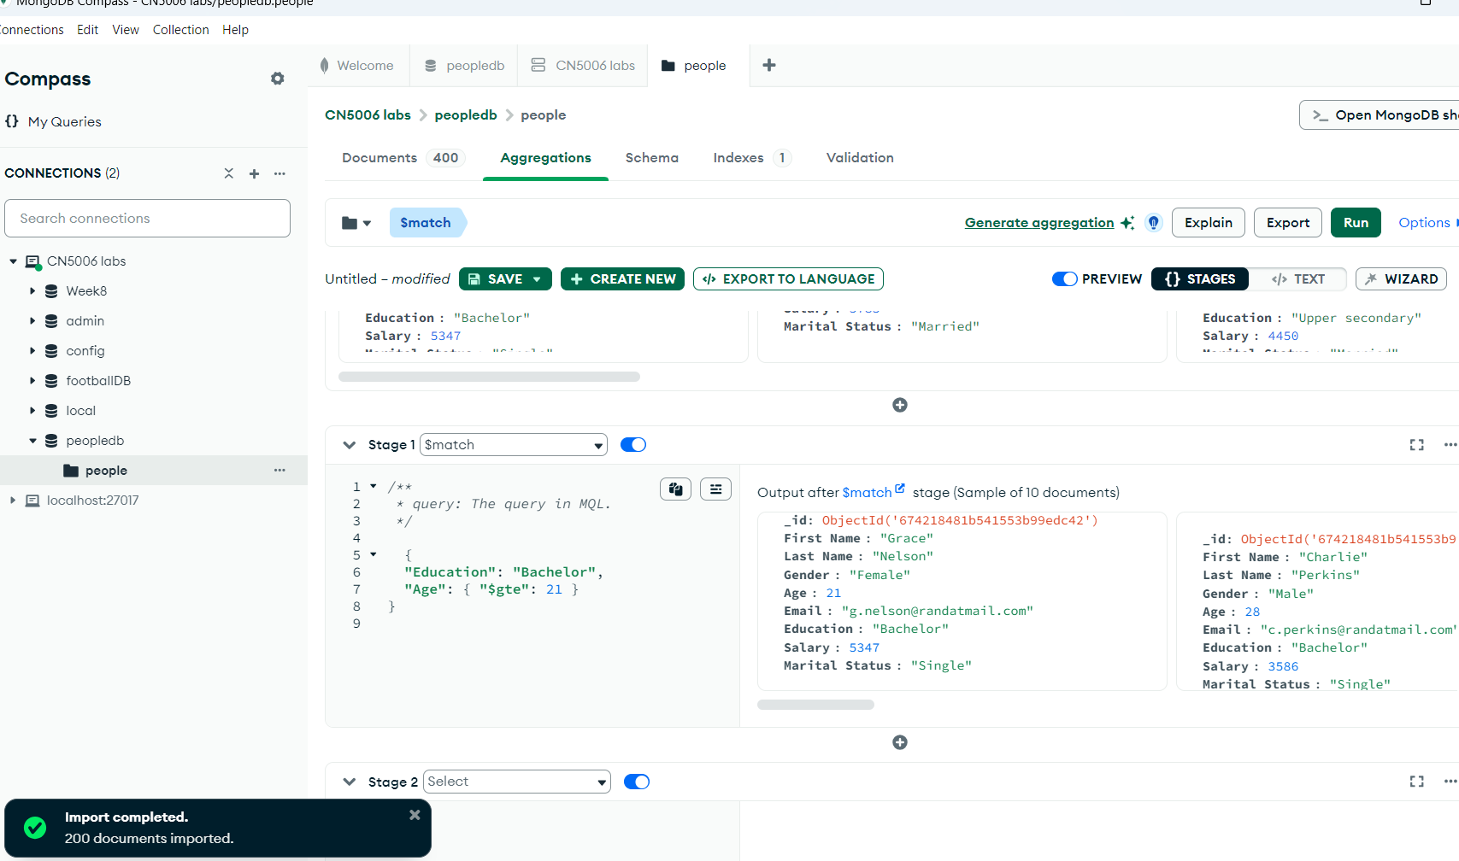

**Explanation: This will filter documents where:**

* Education is "Bachelor".
* Age is greater than or equal to 21 ($gte means "greater than or equal to").

**Example 1: Grouping by Gender and calculating the average age of males and females.**

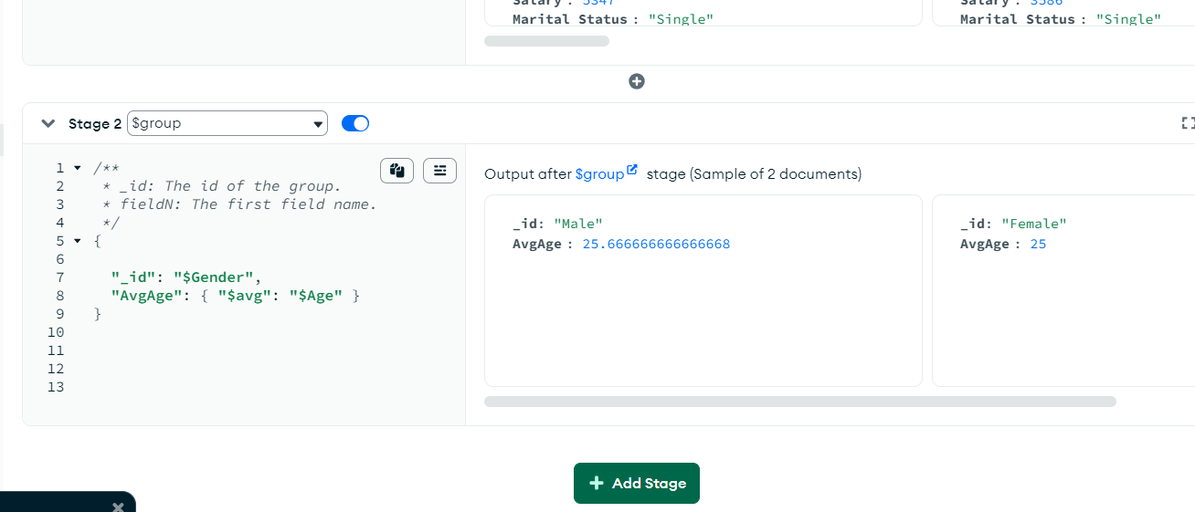

**Explanation:** This groups the data by Gender (e.g., Male, Female) and calculates the average of the Age field for each gender.

**Reflection:**

This week's lab involved CRUD operations and aggregation pipelines, as well as an exploration of MongoDB's document-oriented structure. Making sure JSON syntax was proper when creating aggregate queries was one difficulty I ran into. I resolved these problems by closely examining the MongoDB docs and trying out Compass. The lab emphasised MongoDB's robust aggregation features and flexibility in handling unstructured data, both of which I believe are helpful for managing intricate queries in practical applications**.**

**Harvard style reference:**

**Books:**

Chodorow, K. (2013) *MongoDB: The Definitive Guide*. 2nd ed. Beijing: O'Reilly Media.

**Websites:**

MongoDB, Inc. (2024) *What is MongoDB?*. Available at: <https://www.mongodb.com/what-is-mongodb> (Accessed: 23 November 2024).

MongoDB, Inc. (2024) *MongoDB Compass Documentation*. Available at: <https://www.mongodb.com/docs/compass/current/> (Accessed: 23 November 2024).

**Journal Articles:**

Jones, D. and Smith, R. (2022) 'A Study on MongoDB Performance and Scalability', *International Journal of Database Systems*, 15(3), pp. 125-136. Available at: https://www.example.com/article (Accessed: 23 November 2024).

**General Web Development:**

W3Schools (2024) *HTML and CSS Tutorial*. Available at: <https://www.w3schools.com> (Accessed: 23 November 2024).